**Database Description & Design**

**1-Entity Relationship Diagram:**

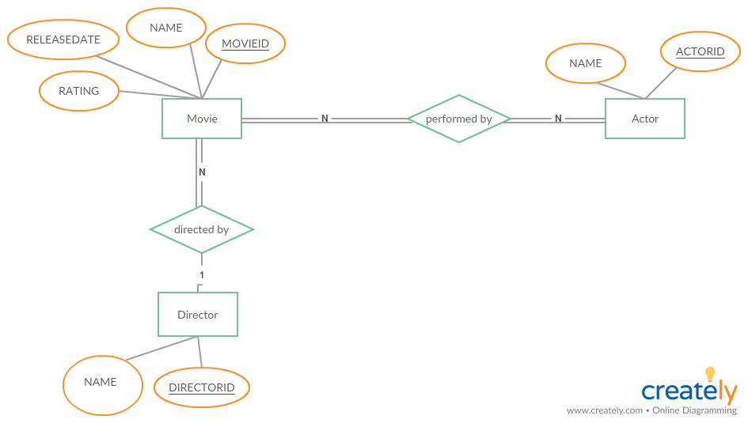

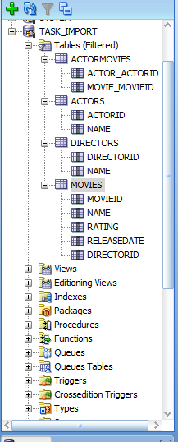**2- SQL Schema & Scripts:**

**2.1 Schema Architecture:**

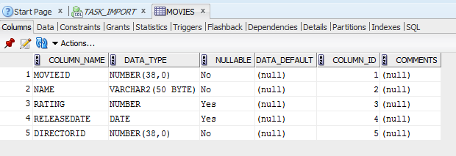**2.2 Movie Table:**

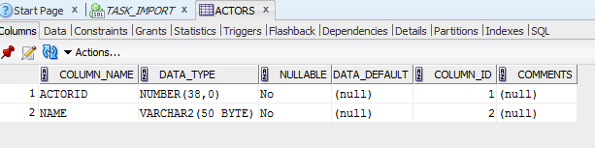**2.3Actor Table:**

**2.4Director Table:**

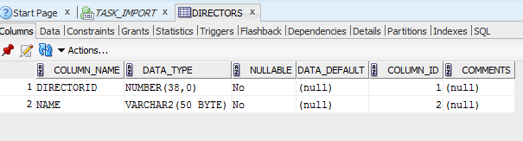

**2.5ActorMovies Table:**

